**Lab Report 2**

**Question 01**: Write a C program to read and print elements of array. – using recursion..

**Source Code :**

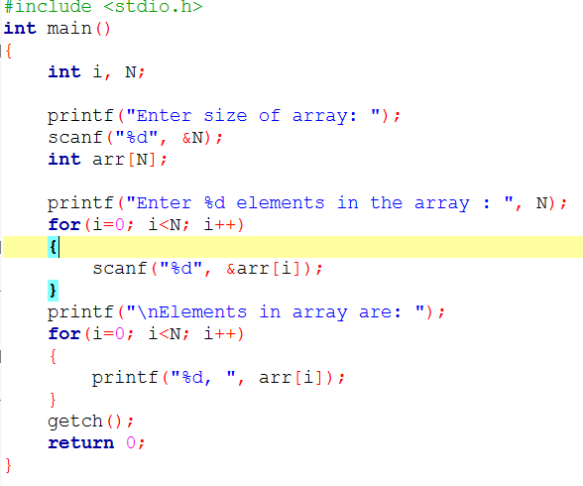

**Output :**

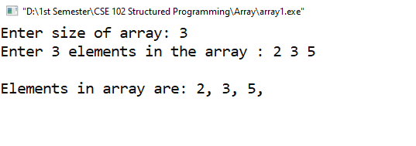

**Question 02**: Write a C program to print all negative elements in an array.

**Source Code :**

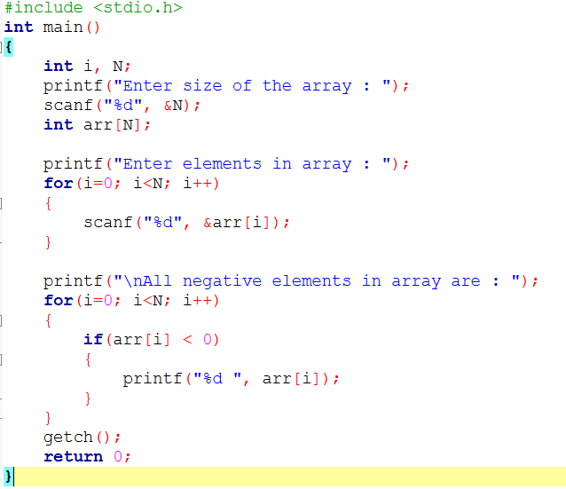

**Output :**

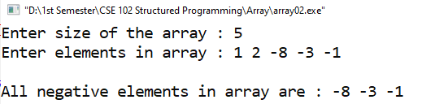

**Question 03 :** Write a C program to find sum of all array elements. – using recursion.

**Source Code :**

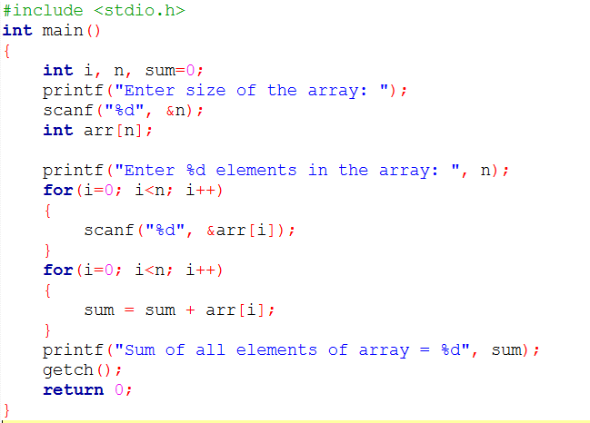

**Output :**

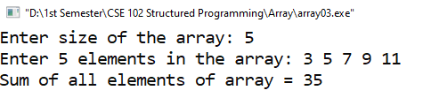

**Question 04 :** Write a C program to find maximum and minimum element in an array. – using recursion.

**Source Code :**

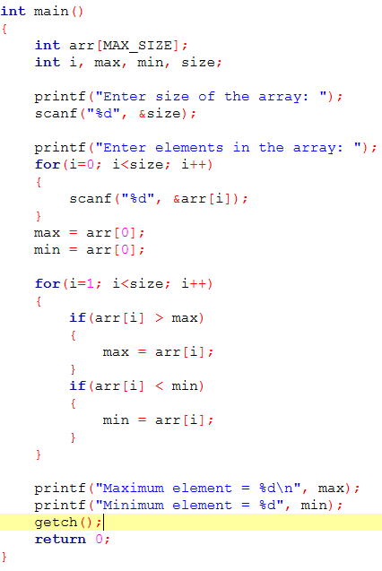

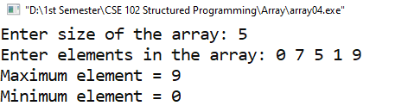**Output :**

**Question 05 :** Write C program to search element in an array.

**Source Code :**

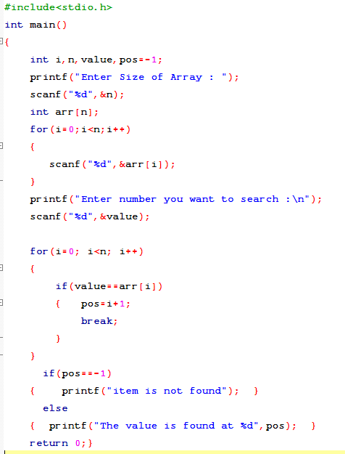

**Output :**

